Formula sheet
Equations
Newton’s law of universal gravitation | 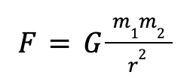  where G=6.67ｘ10⁻¹¹ Nm2kg-2
Weight and mass equation | W = m * g  where g is the gravitational field strength  On Earth, g=9.81 N kg-1
Mole conversions | m = n M  Where m = mass, n = # of moles, and M = molar mass
Avogadro’s constant | 6.02 x 10²³ mol⁻¹

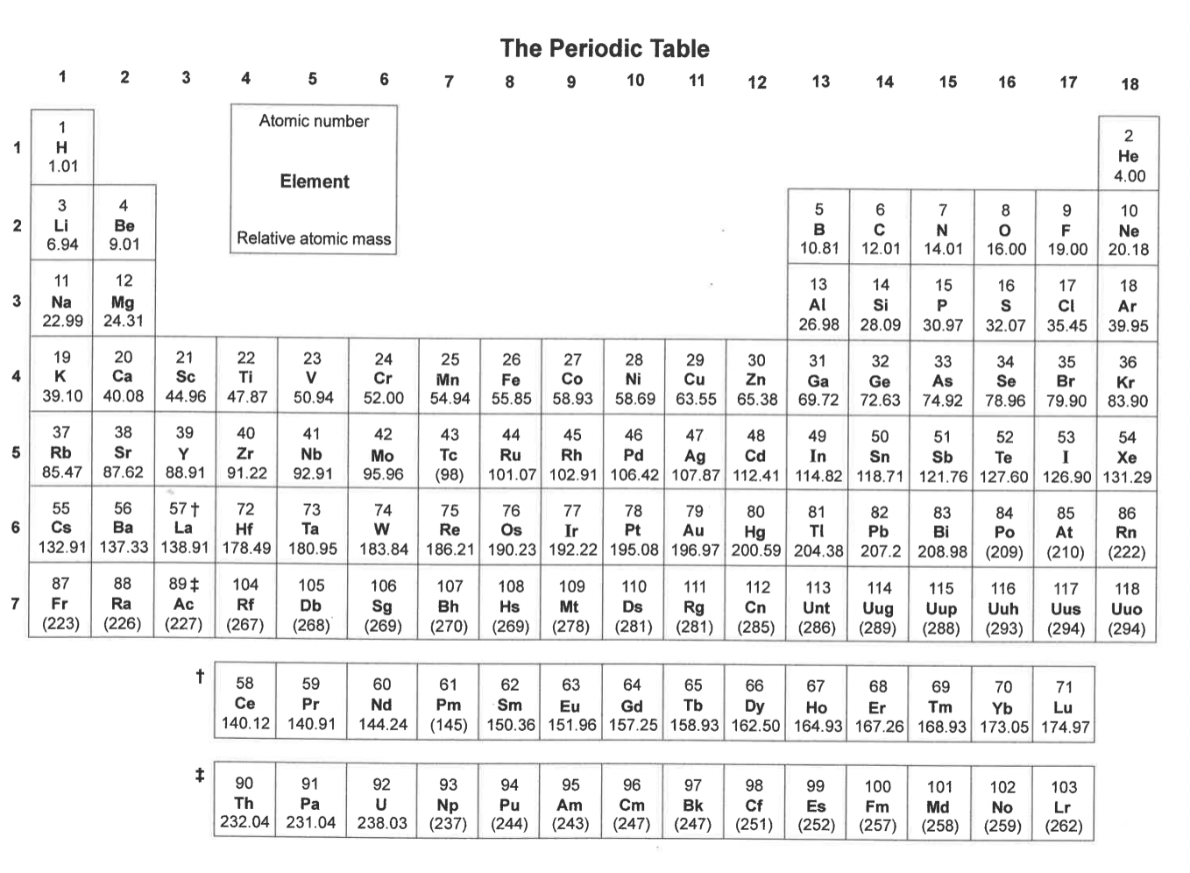
Section 1: Quickfire questions

- Which is the strongest of the four fundamental forces?

______________________________________________________________________

- Which has the largest range?

______________________________________________________________________

- Which subatomic particles are found in the nucleus of an atom?

______________________________________________________________________

- What is the unit of mass?

______________________________________________________________________
- What is the unit of weight?
______________________________________________________________________

Section 2: Short Answer Questions
- Elemental Composition:
  - An atom has 12 protons, 12 neutrons, and 10 electrons.
a. What is the charge of this atom?

b. What is the atomic number?

c. What is the mass number?

- Describe what an isotope means:

______________________________________________________________________

______________________________________________________________________

______________________________________________________________________

- Describe what an ion means:

______________________________________________________________________

______________________________________________________________________

______________________________________________________________________

- What does the “relative” in relative atomic mass mean (Eg. Hydrogen mass is 1.01)?

______________________________________________________________________

______________________________________________________________________

______________________________________________________________________

- Difference Between Concepts:
  - Describe the differences between mass and weight, and explain why astronauts weigh less on the Moon.

______________________________________________________________________

______________________________________________________________________

______________________________________________________________________

- Calculation of Weight:
  - A dog has a mass of 25 kg. Calculate its weight on Earth, where g=9.81

Section 3: Periodic Table Practice
- Fill in the table for the following elements:
Element Symbol | Atomic Number | Mass Number | Protons | Neutrons | Electrons
Mg | 12 | 24
F | 9 | 19

- Draw the electron shell diagrams for the following:
a. Sodium (Na)

b. Fluorine (F)

Describe why atoms in the periodic table have a net charge of 0.

______________________________________________________________________

______________________________________________________________________

Section 4: Application and Analysis
- A necklace contains 184 g of gold (Au)
a. Calculate the number of moles of gold in the necklace.

b. How many atoms of gold are in the necklace?

A student requires 2 moles of glucose, which has the formula C₆H₁₂O₆, to carry out an experiment.
- Calculate the mass of C₆H₁₂O₆ that the student will need to weigh out for this reaction.
- Calculate the number of molecules in 1.5 moles of C₆H₁₂O₆.
- Calculate the number of oxygen atoms in 1.5 moles of C₆H₁₂O₆.

- Two students have been separated in class and are sitting at a distance of 12m from each other. Their masses are 67kg and 54kg. Calculate the gravitational force between the two students.

- Calculate the gravitational force a small car (400 kg) experiences on the surface of earth.

- Between these three forces: the weak interaction, gravitational force and electromagnetic force, describe on what scale they are dominant and give an example for each.

______________________________________________________________________

______________________________________________________________________

______________________________________________________________________

______________________________________________________________________

______________________________________________________________________

Section 5: Scientific Inquiry
- Scenario:
A scientist observes that the gravitational field strength on a mountain peak is slightly less than at sea level.
a. Suggest a reason for this difference.

______________________________________________________________________

______________________________________________________________________

______________________________________________________________________

______________________________________________________________________

- Predict whether the gravitational field strength on Mars would be higher or lower than on Earth and justify your answer.

______________________________________________________________________

______________________________________________________________________

______________________________________________________________________

______________________________________________________________________

______________________________________________________________________

______________________________________________________________________

